**Microstation CE Stream Table Tool**

1. Deploy the tool:

* Unzip the **StreamTableTool.zip** to a local folder.
* Add the folder path into configuration variable **MS_ADDINPATH**

1. Load the tool:

* To load the tool, key in “**mdl load StreamTableTool**”
* To show the tool, key in “**streamtabletool open**”

1. Requirements for Stream table data spreadsheet:

* Stream properties are in columns, stream data are in rows.
* Stream numbers must be in the first column.
* There must be a “**unit**” in first column for unit rows.
* The property names must be unique, no duplicates.

1. Steam Bubble

* The stream number pattern is multiple digit numeric plus one optional letter.
* A valid stream bubble should a tag element with tag name as “ITEMTAG” and tagset name as “PFD_STREAM_SQ” OR “PFD_STREAM_CIR” as defined in **StreamTableTool.xml.**
* A screenshot of a computer

  Description automatically generated

1. Configuration

* Edit **StreamTableTool.xml** for configuration.

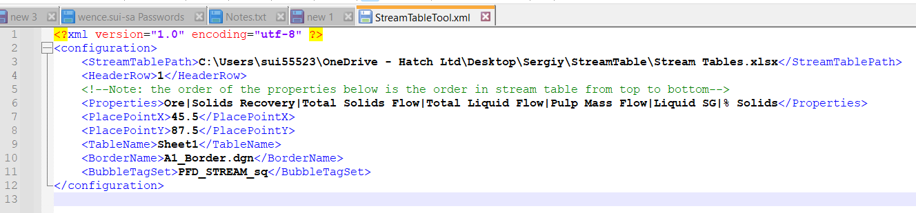

* Put requested properties in “Properties” node and separate them by vertical bar. The order of the properties in this node from left to right is the order of them in PFD from top to bottom.

1. Border

* Border defined in xml must be attached to drawing, and display is on.
* A line string (color 0 and line weight 2) in the border is used to define the working area.

1. The tool uses the cell library **StreamTableElement.cel** which will be attached when the tool is loaded. If it’s detached in the middle, click “**Re-Attach Cell Lib**” botton.
2. The stream table spreadsheet can be opened in Excel while the tool is being used. If data in spreadsheet is changed, click “**Re-Load Steam Data**”.